**Nama : Firly Nurlya Rahim**

**NPM : 4510210032**

**Praktikum Pemrograman 4 – Sesi 2**

* Membuat folder menggunakan maven

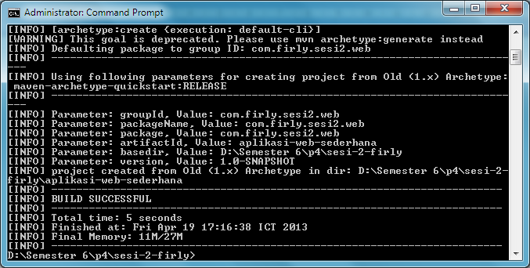

* Mengaktifkan tomcat

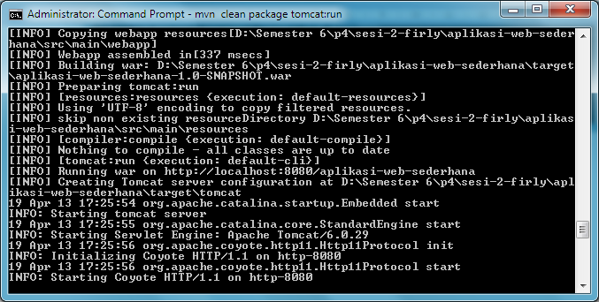

* dateandtime.jsp

<%@ page import="java.io.*,java.util.*" %>

<%@ page import="javax.servlet.*,java.text.*" %>

<html lang="id">

<head>

<title>Belajar JSP</title>

</head>

<body>

<section>

<h2><center>Tanggal dan Waktu</center></h2>

<center>

<%

Date dNow = new Date( );

SimpleDateFormat dateFormat = new SimpleDateFormat ("EEEE , d MMMM y");

SimpleDateFormat timeFormat = new SimpleDateFormat ("HH:mm:ss");

out.print( "<h4 align=\"center\">Hari dan tanggal saat ini : " + dateFormat.format(dNow) + "</h4>");

out.print( "<h4 align=\"center\">Waktu saat ini :" + timeFormat.format(dNow) + "</h4>");

%>

</center>

</section>

</body>

</html>

* Printscreen

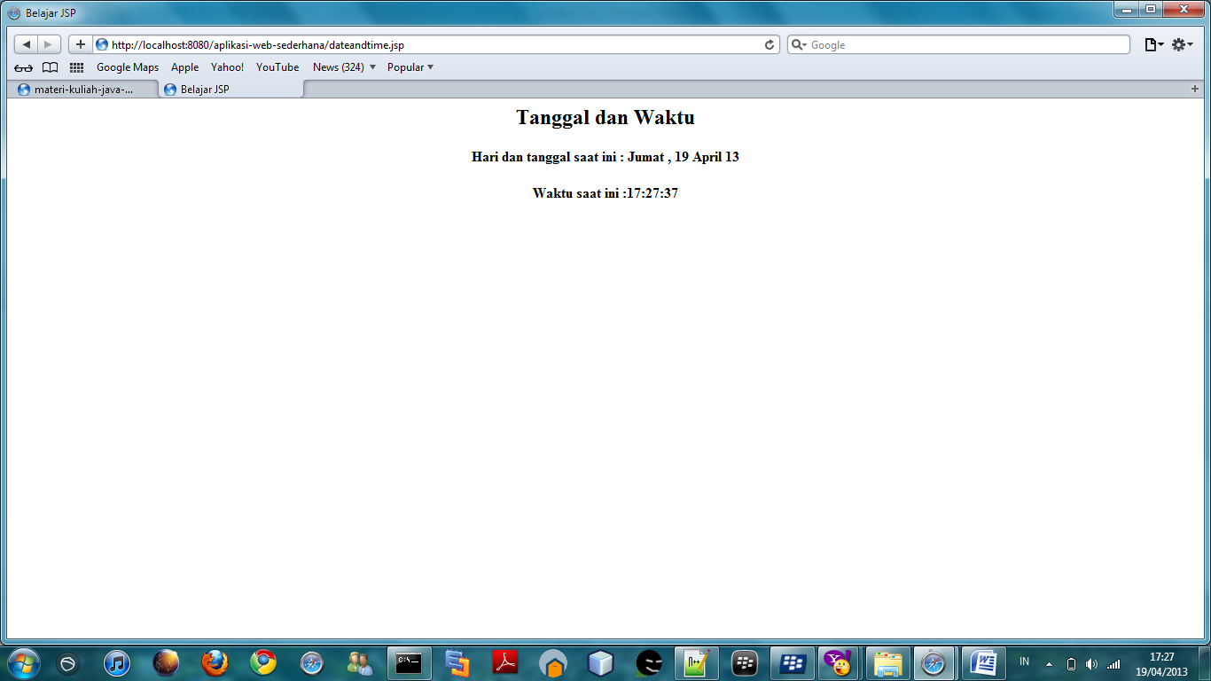

* form.html

<html>

<head>

<body>

<form action="verifikasi.jsp" method="POST">

<h2>Input Data</h2>

<table>

<tr><td>Nama</td>

<td> :</td>

<td><input type="text" name="nama"></td>

</tr>

<tr>

<td>Email</td>

<td>: </td>

<td><input type="text" name="email"></td>

</tr>

<tr>

<td>Tanggal Lahir</td>

<td>:</td>

<td><input type="text" name="tgl_lahir"></td>

</tr>

<tr>

<td>Alamat </td>

<td>:</td>

<td><input type="textarea" name="alamat"></td></tr>

<tr><td><input type="submit" value="Simpan"></td></tr>

</table>

</form>

</body>

<head>

</html>

* Printscreen

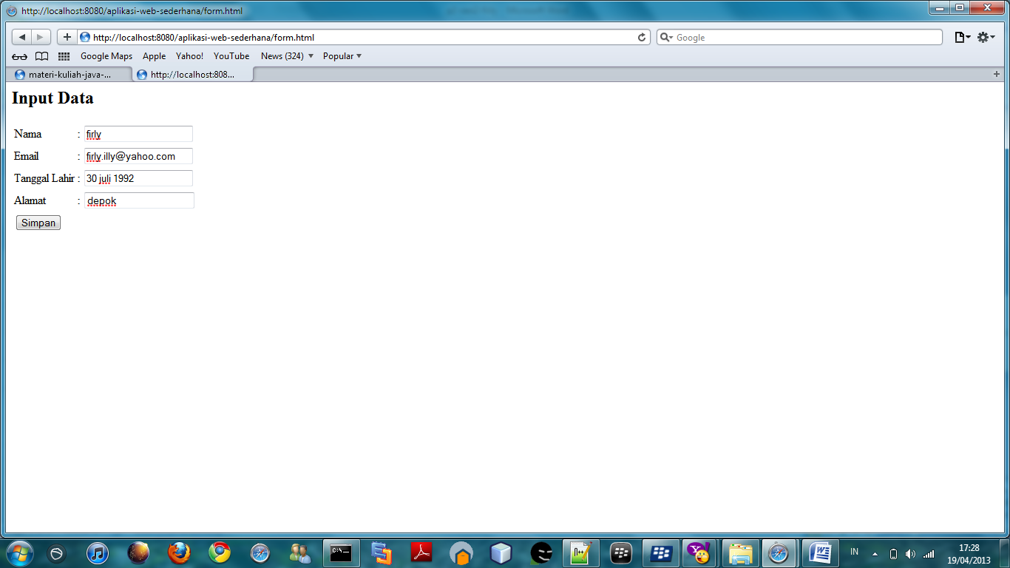

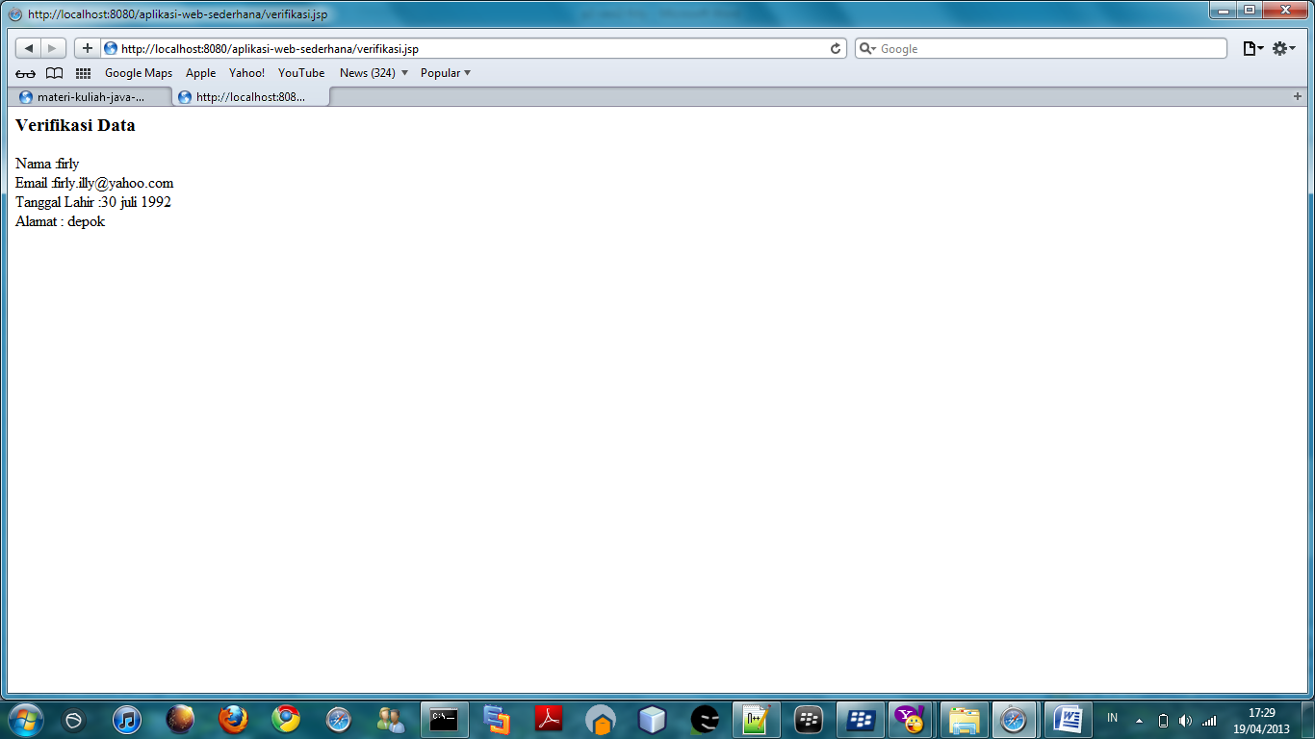

* Produk.jsp

<%@ page import="java.io.*,java.util.*,java.sql.*"%>

<%@ page import="javax.servlet.http.*,javax.servlet.*" %>

<%@ taglib uri="http://java.sun.com/jsp/jstl/core" prefix="c"%>

<%@ taglib uri="http://java.sun.com/jsp/jstl/sql" prefix="sql"%>

<html>

<head>

<title>SELECT Operation</title>

</head>

<body>

<sql:setDataSource var="snapshot" driver="com.mysql.jdbc.Driver"

url="jdbc:mysql://localhost/produk"

user="root" password=""/>

<sql:query dataSource="${snapshot}" var="result">

SELECT * from produk;

</sql:query>

<table border="1" width="100%">

<tr>

<th>kode</th>

<th>nama</th>

<th>harga</th>

<th>terakhir update</th>

</tr>

<c:forEach var="row" items="${result.rows}">

<tr>

<td><c:out value="${row.id}"/></td>

<td><c:out value="${row.kode}"/></td>

<td><c:out value="${row.harga}"/></td>

<td><c:out value="${row.terakhir_update}"/></td>

</tr>

</c:forEach>

</table>

</body>

</html>

* Printscreen

